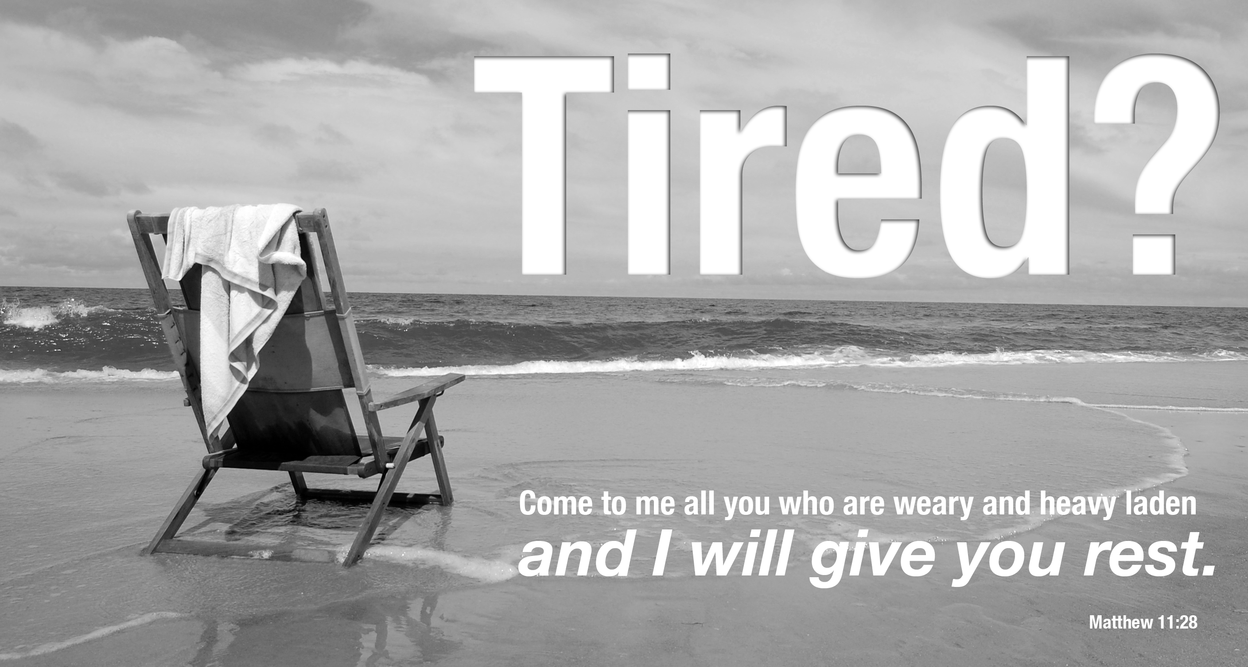
COME AND BE REFRESHED
DISCOVERING CHRIST
FRIDAYS AT 6:45 PM FROM JUNE 4 TO JULY 23
Join us for Discovering Christ. Enjoy a free dinner, listen to a dynamic teaching, and join in a small group discussion about the meaning of life in Jesus Christ. Discovering Christ is a seven-week series that will begin Friday, June 4 at the St. Agnes Parish Center. Also mark your calendars for a life-changing retreat on Saturday, July 10.

Learn more about the course at www.parishwebsite.com/christlife

REGISTRATION FORM / DISCOVERING CHRIST COURSE / JUNE 4 - JULY 23, 2010 / ST. AGNES PARISH

NAME(S): _____________________________________________________ AGE: _________
EMAIL: _______________________________________ PHONE: _______________________
Return this form to the St. Agnes Parish Office: 5422 Old Frederick Rd. Baltimore, MD 21229
or email us at discoverchrist.stagnes@gmail.com

