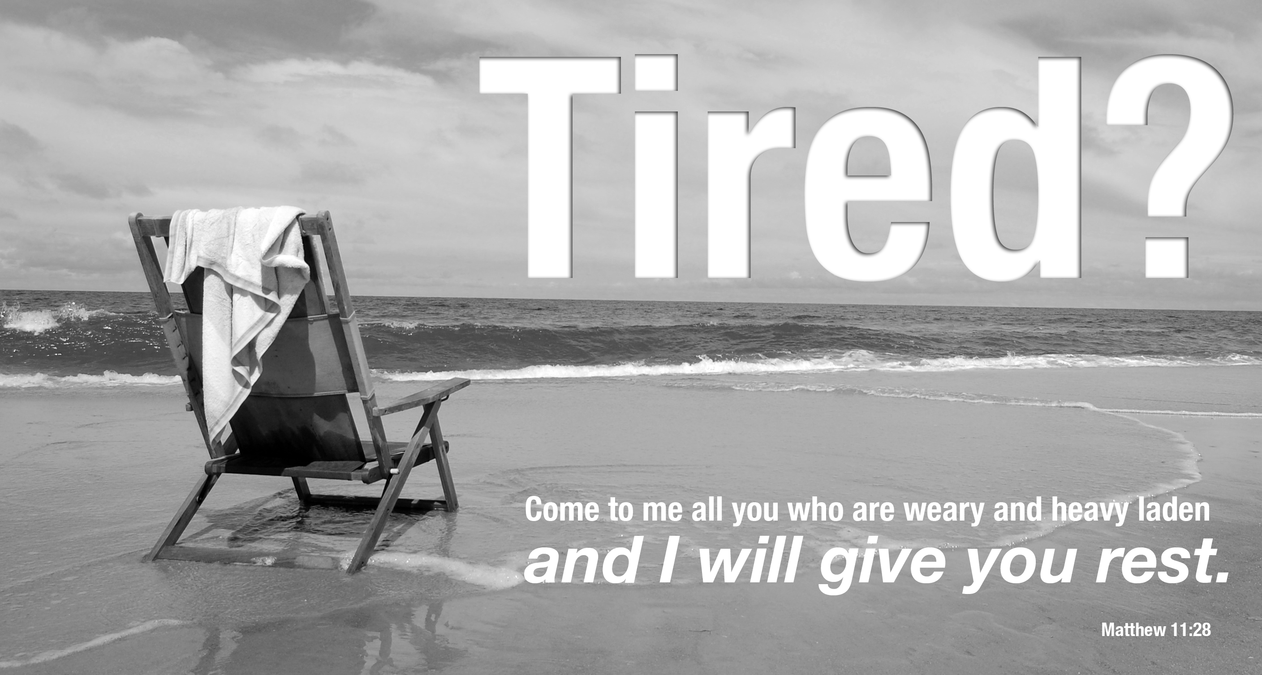
COME AND BE REFRESHED
DISCOVERING CHRIST
FRIDAYS AT 6:45 PM FROM JUNE 4 TO JULY 23
Please join us in the new St. Agnes Parish Activities Center for Discovering Christ. Enjoy a free dinner, listen to a dynamic teaching and join in a small group discussion about the meaning of life in Jesus Christ. Discovering Christ is a seven-week series that will begin Friday, June 4, and includes a life-changing retreat on Saturday, July 10.
We invite you to watch a Discovering Christ youtube video to learn more about the course: http://www.youtube.com/watch?v=5-QPh2_3n2k
or find us on Facebook by searching for “St. Agnes Parish, Baltimore MD”
This course is designed to revitalize your faith or to bring your family and friends who have been away from the church.

Discovering Christ was developed by ChristLife, a Catholic ministry in the Archdiocese of Baltimore.
REGISTRATION FORM / DISCOVERING CHRIST COURSE / JUNE 4 - JULY 23, 2010 / ST. AGNES PARISH

NAME(S): _____________________________________________________ AGE: _________
EMAIL: _______________________________________ PHONE: _______________________
Return this form to the St. Agnes Parish Office: 5422 Old Frederick Rd. Baltimore, MD 21229
or email us at discoverchrist.stagnes@gmail.com

